Mid-Atlantic Solid Axle Corvette Club

Spring Lake, NJ

October 15 to October 17**,** 2025

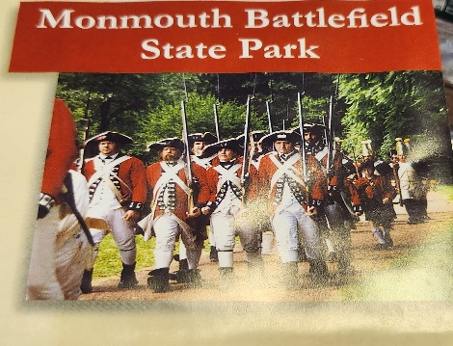 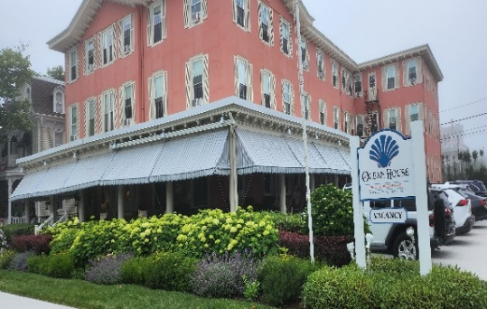 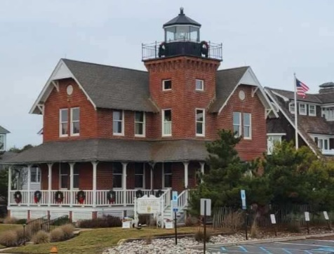

Monmouth Battlefield State Park Ocean House Bed & Breakfast Hotel Sea Girt Lighthouse

Our Fall event brings us to Spring Lake, NJ. We will be staying at the Ocean House Bed & Breakfast Hotel in Spring Lake, NJ for two nights 10/15 & 10/16/ 2025 (www.theoceanhouse.net) as our home base.. Reservation will be made by each member through the website or by calling directly telephone 732-449-9090. When making the reservation use the code:RickH2025.

We will start by meeting on Wednesday 10/15/25 afternoon at 1:00 pm at the Monmouth Battlefield State Park (www.njparksandforest.org) located at 20 State Route 33, Manalapan, NJ 07726. There is a large parking lot and we can gather at the entrance area of the exhibit. No fees will be charged however memorabilia may be purchased. Restrooms are located inside the exhibit. After touring the exhibit we will drive to the Ocean House in Spring Lake for Check-in which starts at 3:00 pm. For dinner that night we will dine on pizza that will be delivered to the hotel and paid for by MASACC treasury. We will order pizzas from the pizzeria menu and any dietary needs can be addressed at that time. Please bring any beverages and snacks to be enjoyed during the evening.

On Thursday we will be served breakfast from a menu selection the night before supplied by the Ocean House starting from 8:30 am. After breakfast we will take a short 10 minute drive to Sea Girt, NJ to take a guided tour of the Sea Girt Lighthouse ([www.seagirtlighthouse.com](http://www.seagirtlighthouse.com)).

After our guided tour of the Sea Girt Lighthouse we take our cars for a short 15 minute drive to the Belmar Marina for a Whale Watching Tour on the SS Miss Belmar ship. Cost is $45 per person senior rate, tour is for 3 hours starting at 1:30 pm. We need to be at the dock by 1:00 pm for boarding. I will need to book our reservations ahead of time to insure availability. Website (<https://missbelmar.com>).

That night we will dine at the Marina Grille ([www.marinagrillenj.com](http://www.marinagrillenj.com)) which is located right in the Belmar Marina just a short walk from when we dock back at the marina from our whale watching tour. Couples or Individuals will be responsible for their own checks. After we will return to the Ocean House for an evening of relaxation and conversation.

On Friday morning once again breakfast will be served as fore mentioned as on Thursday. Checkout time is 11:00 am. Afterward if desired a short walk or drive into the quaint town of Spring Lake for shopping and coffee. Members depart for home at their own discretion.

Have a safe drive home. .

Hope to see you there,

Rick Helwig and Frank Pinkus

**Mid-Atlantic Solid Axle Corvette Club**

Spring Lake, NJ

October 15 – October 17, 2025

Please indicate the events you plan to attend

# Wednesday, October 15

___ 1:00pm Monmouth Battlefield State Park Visitors Center – tour the visitors center

___ 1:30-3:30pm Tour exhibits of the Monmouth Battlefield

|  |  |
| --- | --- |
| ___ 4:00pm | Check in at Ocean House B&B Hotel (Individual registration fee). |
| ___ Evening | Pizza dinner at Ocean House covered by MASACC treasury, Overnight stay at Ocean House B&B Hotel. |

# Thursday, October 16

|  |  |
| --- | --- |
| ___ 10:15am | Leave hotel |
| ___ 10:30-12:30pm | Tour the Sea Girt Lighthouse |
| ___ 12:30pm | Drive to Belmar Marina |
| ___ 1:00-4:30pm | Board the SS Miss Belmar for Whale Watching Tour (1:30PM – 4:30pm |
| ___ 5:30-8:30pm | Dinner Marina Grille (individual checks), Overnight Ocean House B&B Hotel |

# Friday, October 17

|  |  |
| --- | --- |
|  | Optional-stroll the shops and historic buildings on Main Street, Spring Lake, NJ |

Lunch on your own and depart for home

Registration Fee $15 X _____ people = $______

Monmouth Battlefield State Park (No Charge) $ 0X _____ people = $__0____

Sea Girt Lighthouse Tour (No Charge) $ 0X _____ people = $__0____

Whale Watching Tour $45 X _____ people = $_______

TOTAL $ ______

Send this registration form and a check made payable to **Mid-Atlantic SACC** to Rick Helwig, MASACC, 79 Nicole Drive, Brick, NJ 08724 Late registration fee of $20.00 per person will be charged after October 1, 2025.

Name ____________________________________________________________________

Name of 2nd person __________________________________________________________

Address ___________________________________________________________________

City __________________________________________ State _______ Zip ___________

Phone ( ) Cell Phone: (____)______________Email _________________________

____I am bringing a Corvette: Year ______ Color ______

I agree to insure my vehicle and property against loss, damage and liability. I agree to assume the risk of any and all damages or injury to indemnify and hold harmless SACC its officers, directors, agents, employees and chapters for any acts or missions which may result in the theft, damage, or destruction of my property or injury to me or others during or as a consequence of the event, wherever located.

Signed________________________________________________ Date__________